**DAY 2**

**Question 1 :**

**CODE:**

(i)b<-c(22, 28, 10)

c<-c(20, 40, 40)

cov(b,c)

(ii)a<-c(18, 2, 20)

b<-c(22, 28, 10)

c<-c(20, 40, 40)

pre<-cbind(a,b,c)

cov(pre)

(iii).b<-c(22, 28, 10)

c<-c(20, 40, 40)

cor(b,c)

(iv)a<-c(18, 2, 20)

b<-c(22, 28, 10)

c<-c(20, 40, 40)

pre<-cbind(a,b,c)

cor(pre)

**OUTPUT:**

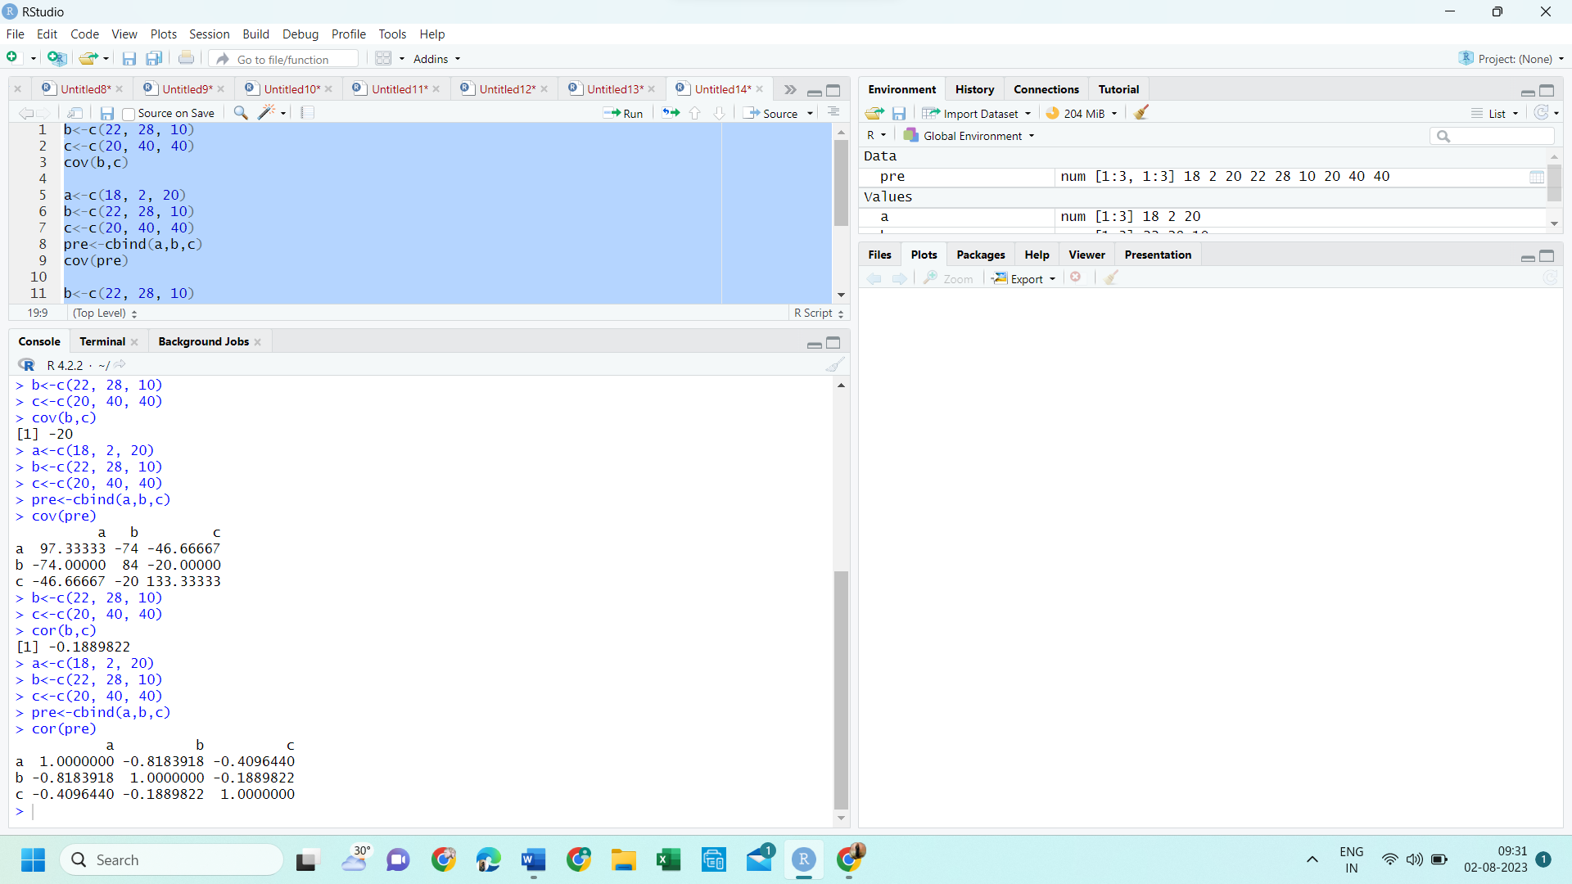

**Question 2 :**

**CODE :**

data<-c(1, 1, 5, 5, 5, 5, 5, 8, 8, 10, 10, 10, 10, 12, 14, 14, 14, 15, 15, 15, 15, 15, 15, 18, 18, 18, 18, 18, 18, 18, 18, 20, 20, 20, 20, 20, 20, 20, 21, 21, 21, 21, 25, 25, 25, 25, 25, 28, 28, 30, 30, 30)

bin<-length(data)/3

bins<-cut(data, breaks = c(-Inf, quantile(data, probs = seq(0,1, 1/3)),Inf), include.lowest = TRUE)

tapply(data,bins,mean)

tapply(data, bins,function(x) c(min(x),max(x)))

hist(data,breaks = 3, main = "Histogram", xlab = "prices")

**OUTPUT:**

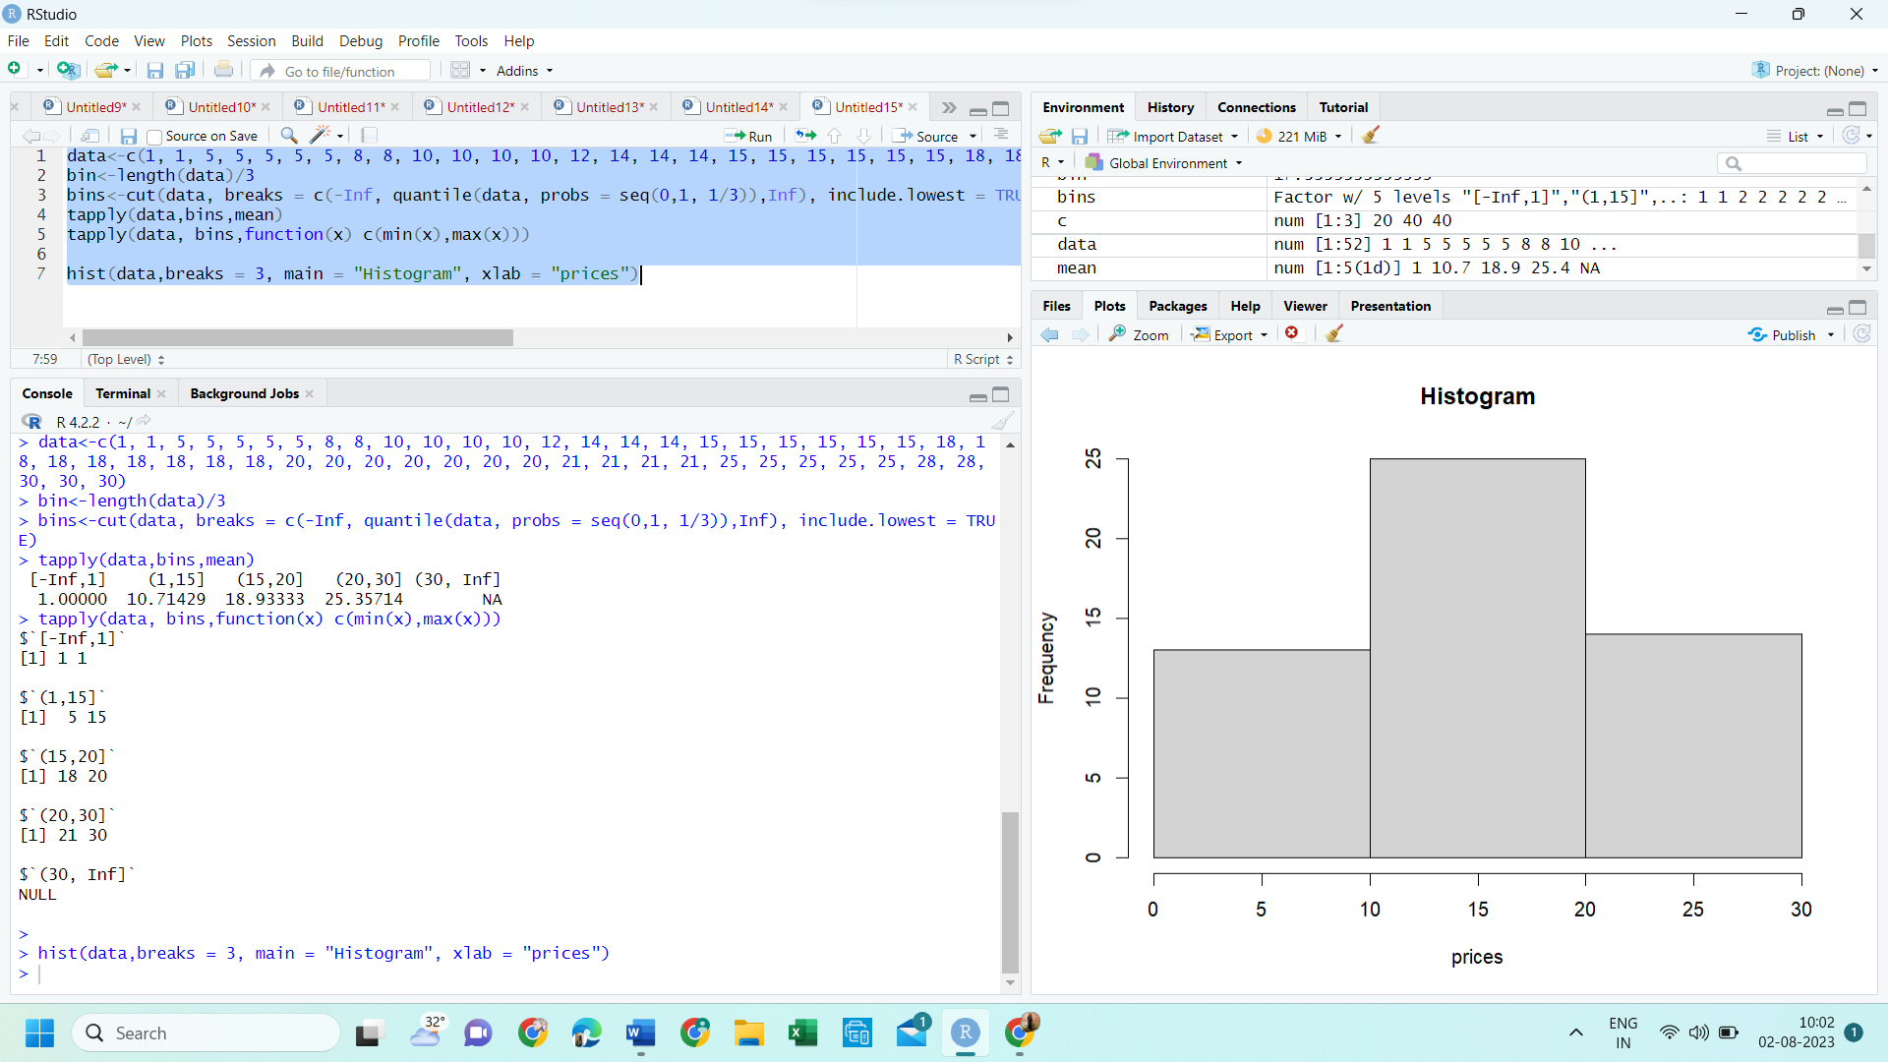



**QUESTION 3 :**

**CODE:**

A <- c(76, 35, 47, 64, 95, 66, 89, 36, 84)

B <- c(51, 56, 84, 60, 59, 70, 63, 66, 50)

mean_A <- mean(A)

median_A <- median(A)

range_A <- max(A) - min(A)

mean_B <- mean(B)

median_B <- median(B)

range_B <- max(B) - min(B)

combined_data <- data.frame(Class = c(rep("A", length(A)), rep("B", length(B))), Score = c(A, B))

boxplot(Score ~ Class, data = combined_data, col = c("blue", "green"), xlab = "Class", ylab = "Scores", main = "Boxplot of Scores by Class")

(II)

combined_data <- data.frame(Class = c(rep("A", length(A)), rep("B", length(B))), Score = c(A, B))

boxplot(Score ~ Class, data = combined_data, col = c("blue", "green"), xlab = "Class", ylab = "Scores", main = "Boxplot of Scores by Class")

**OUTPUT:**

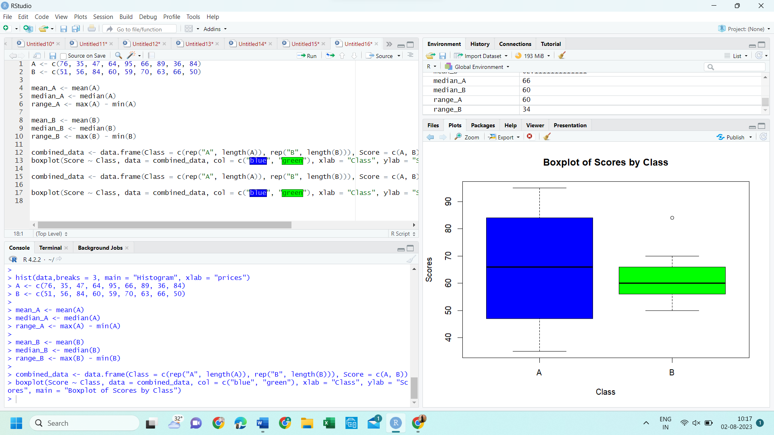

**QUESTION 4 :**

**CODE:**

data <- c(200, 300, 400, 600, 1000)

min_value <- 50000

max_value <- 100000

v <- 80

min_max_normalized <- (v - min_value) / (max_value - min_value)

min_max_normalized

mean_value <- mean(data)

standard_deviation <- sd(data)

z_score_normalized <- (v - mean_value) / standard_deviation

z_score_normalized

**OUTPUT :**

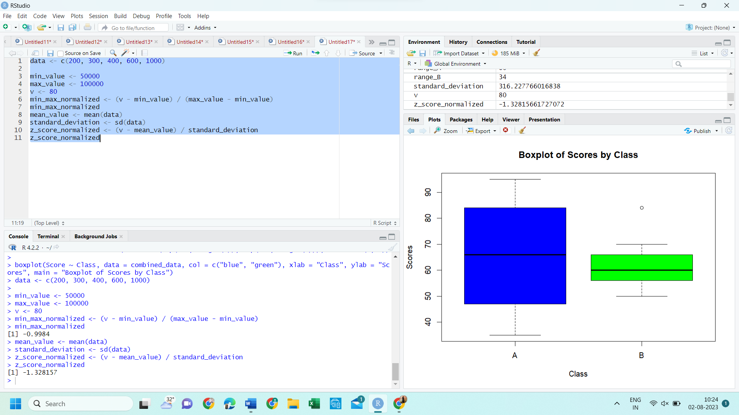

**QUESTION 5 :**

**CODE:**

data("AirPassengers")

hist(AirPassengers, breaks = seq(100, 700, by = 150), col = "blue", main=" Histogram for Airpassengers", xlab = "Passenger count", ylab = "Frequency")

**OUTPUT:**

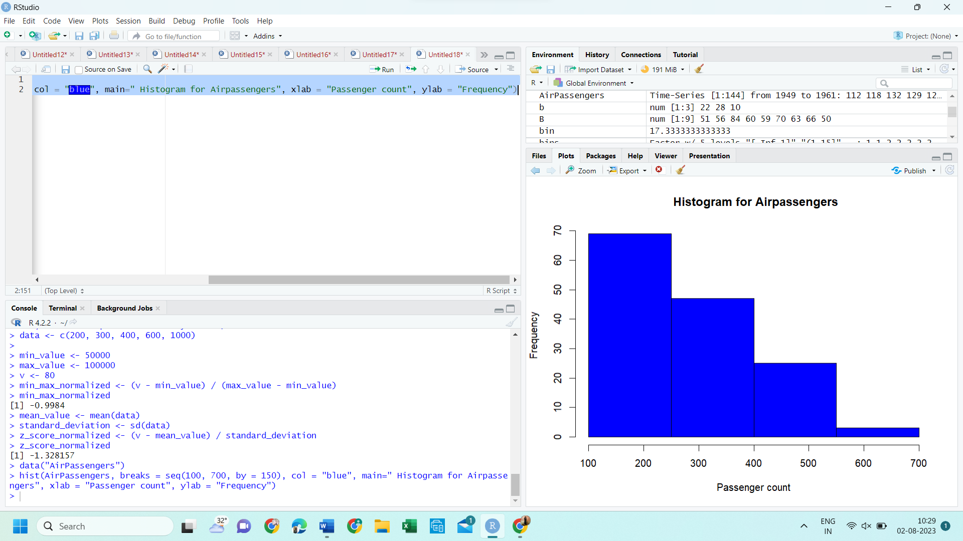

**QUESTION 6 :**

**CODE :**

data("mtcars")

plot(mtcars$mpg, type = "l", col = "blue", xlab = "Index", ylab = "Miles per Gallon", main = "Line Chart of mpg and qsec")

lines(mtcars$qsec, col = "red")

legend("topright", legend = c("mpg", "qsec"), col = c("blue", "red"), lty = 1, cex = 0.8)

**OUTPUT :**

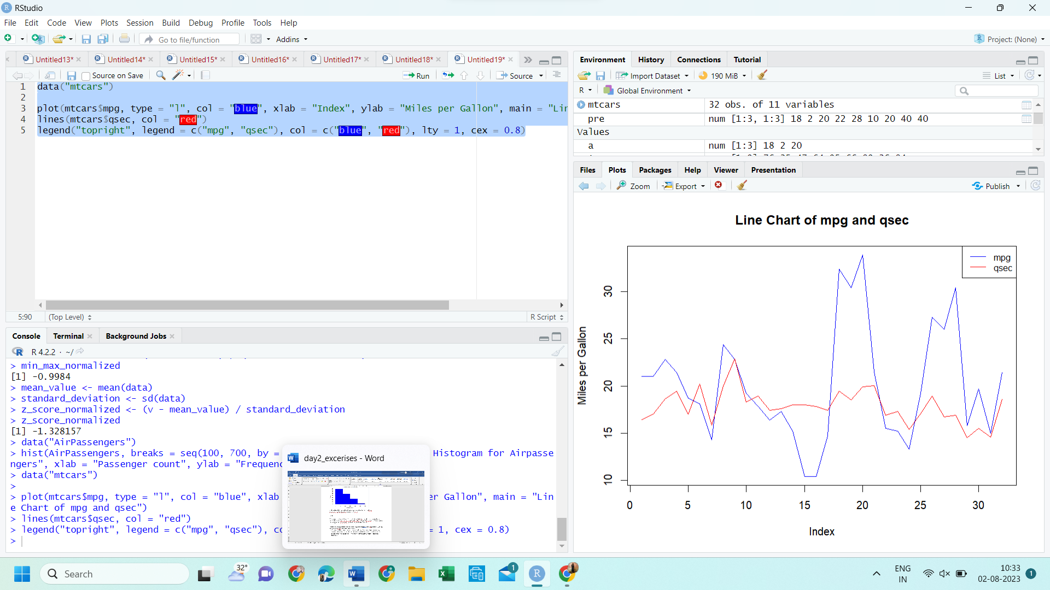

**QUESTION 7 :**

**CODE :**

data("iris")

str(iris)

plot(iris$Sepal.Length, iris$Petal.Length, main = "Scatter plot of Sepal.Length vs. Petal.Length",xlab = "Sepal.Length", ylab = "Petal.Length", col = "blue", pch = 16)

model <- lm(Petal.Length ~ Sepal.Length, data = iris)

abline(model, col = "red")

new_data <- data.frame(Sepal.Length = 5.5)

predicted_Petal_Length <- predict(model, newdata = new_data)

predicted_Petal_Length

**OUTPUT:**

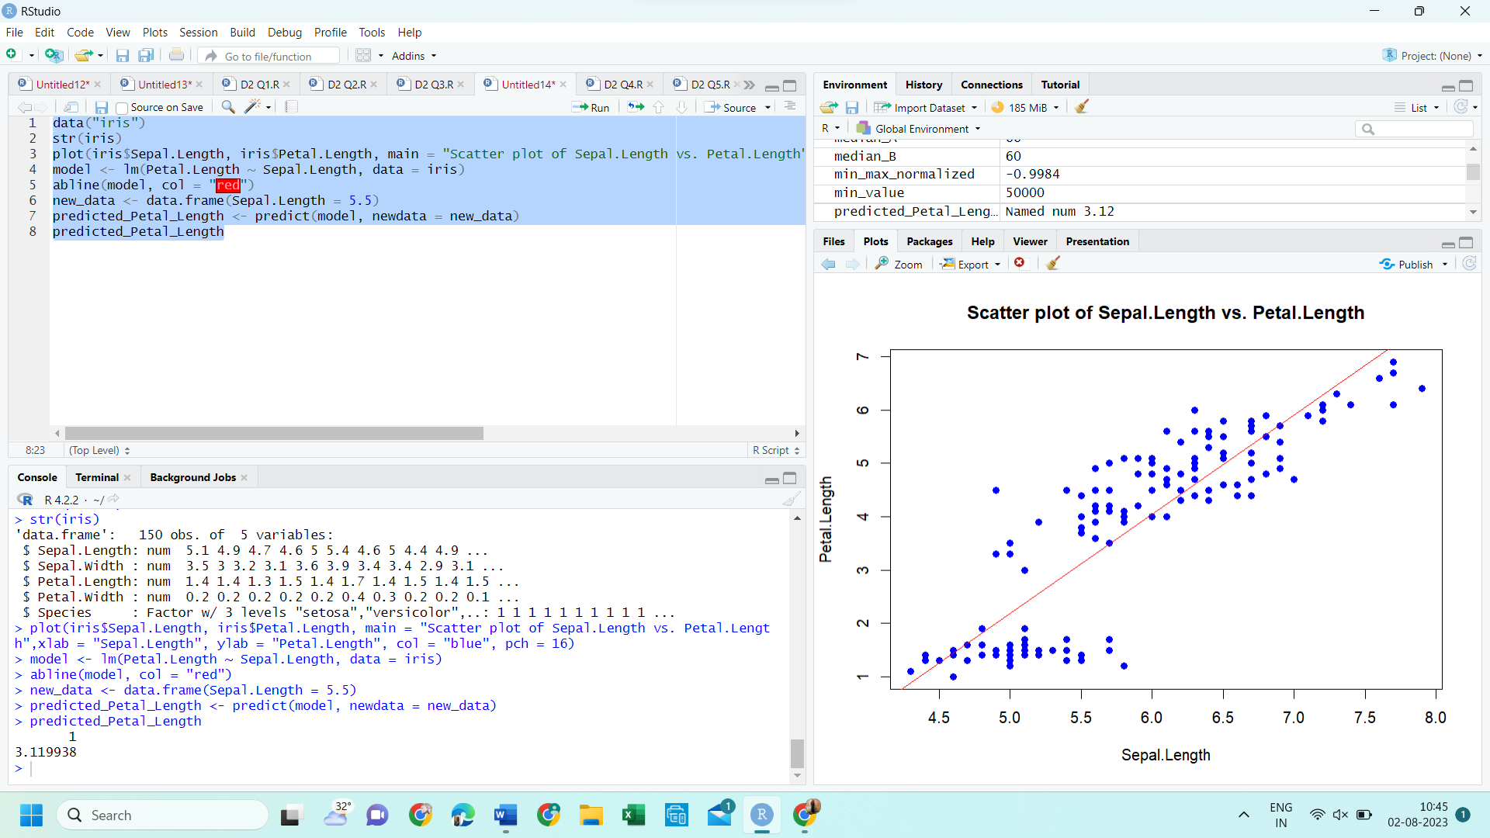

**QUESTION 8 :**

**CODE :**

data("mtcars")

boxplot(mpg ~ cyl, data = mtcars, main = "Boxplot", xlab = "number of cylinders", ylab = "miles per gallon", col= "red")

**OUTPUT :**

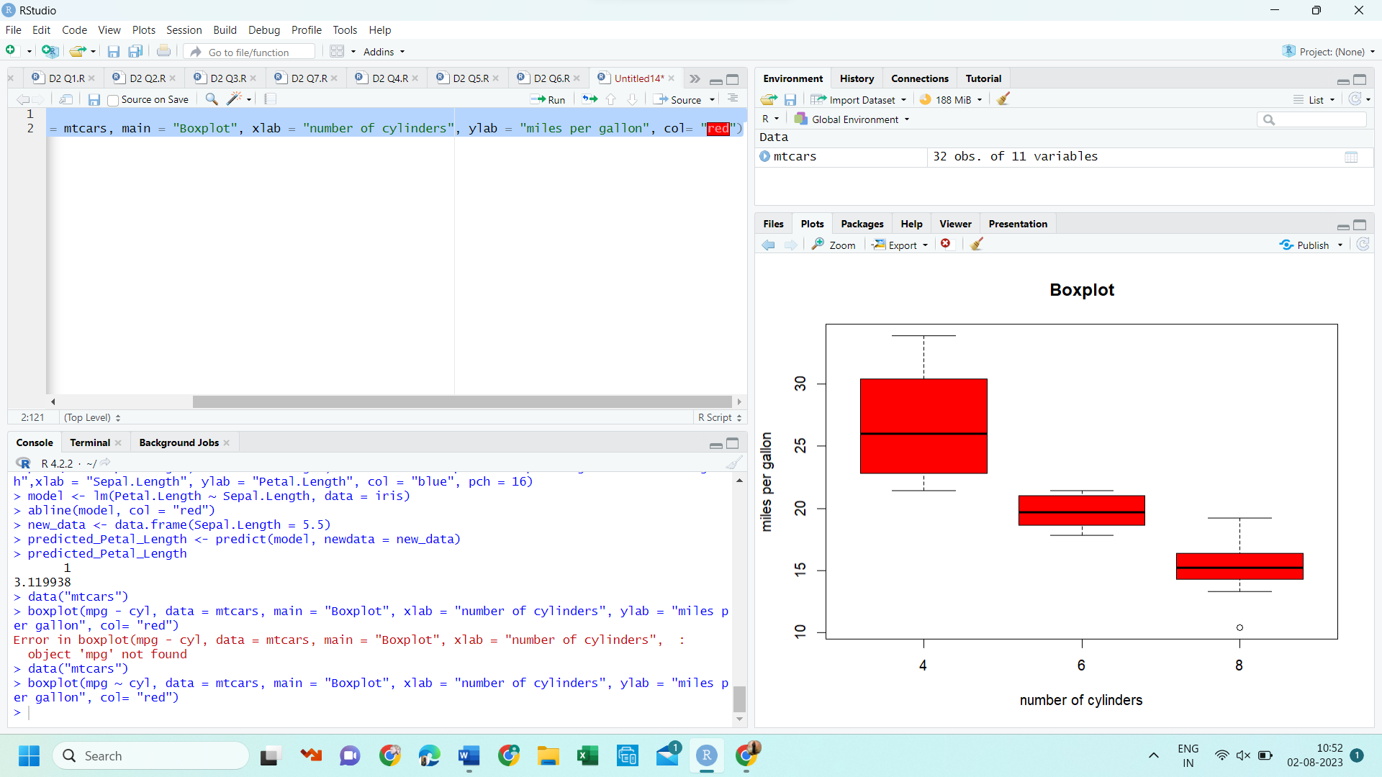

**QUESTION 9 :**

**CODE :**

score <- c(20, 25, 30, 32, 35, 38, 40, 45, 50, 52, 55, 56, 58, 59, 60, 62, 65, 70, 75, 80, 85)

boxplot(score, col = "lightblue", main = "Box Plot of Points Scored by Tennis Players", ylab = "Points Scored")

**OUTPUT :**

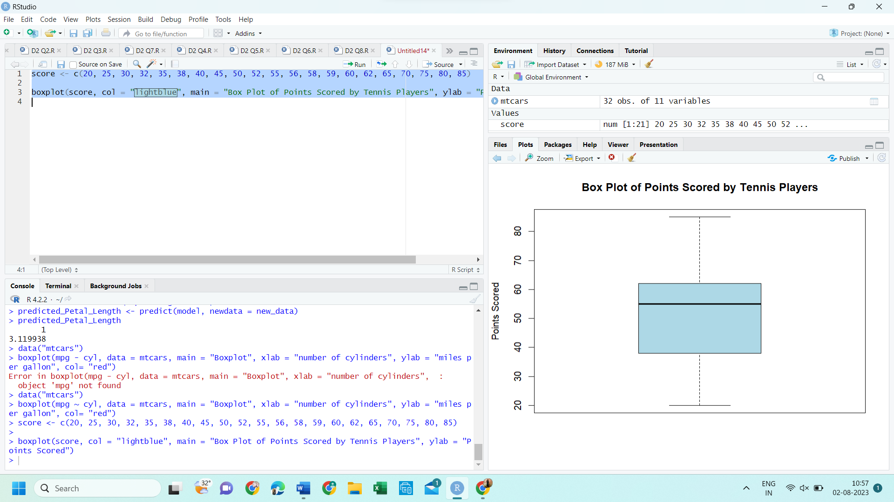

**QUESTION 10 :**

CODE :

dia<-read.csv("C://Users//FLORENCIA ABEL//OneDrive//Documents//diabetes.csv")

View(dia)

plot(dia$Age, dia$BloodPressure, xlab = "Age", ylab = "Blood Pressure", main = "Blood Pressure vs. Age", col = "blue",pch = 16)

age_group_labels <- cut(dia$Age, breaks = c(0, 35, 55, Inf), labels = c("Young", "Middle-aged", "Elderly"))

age_group_avg_bp <- tapply(dia$BloodPressure, age_group_labels, mean)

barplot(age_group_avg_bp, main = "Average Blood Pressure by Age Group",xlab = "Age Group",ylab = "Average Blood Pressure", col = "steelblue", ylim = c(0, max(age_group_avg_bp) * 1.2))

